OPERATING SYSTEMS
WEEK-5 Practical
Name:- CH. Srihitha
Roll no:- 2520030400
Section no:- 9

5Q. Implement a producer-consumer communication system using anonymous pipes where the parent process generates data and the child process consumes it. Measure the communication efficiency.
Develop a program that executes the equivalent of the shell command: ls -l | grep ".c" using fork(), pipe(), dup2(), and exec() system calls.
Program:- 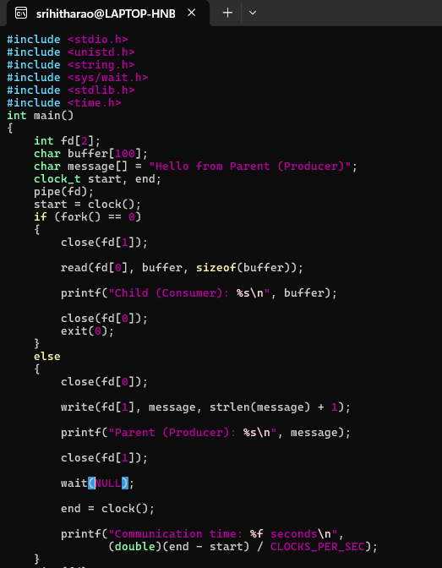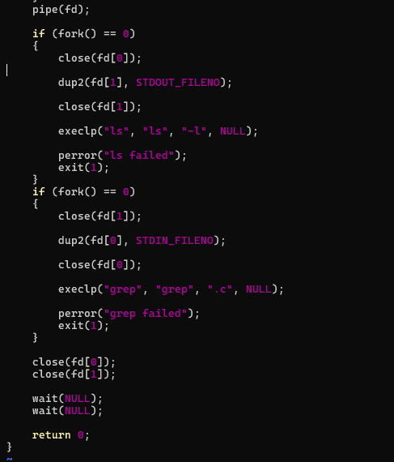

Output:-
